**Week 6-ReactJS-HOL Solutions**

1)ReactJS-HOL

**Setting Up Your First React Application: "myfirstreact" to Display a Welcome Heading**

**Program:**

**File name:app.jsx**

function App() {

return (

<div>

<h1>Welcome to the first session of React</h1>

</div>

);

}

export default App;

**Output:**

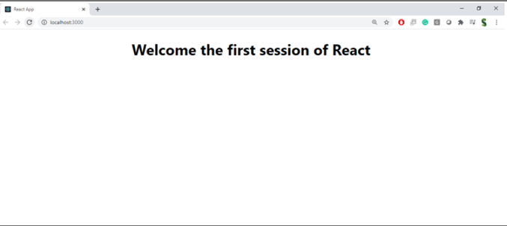

2)ReactJS-HOL

**Building a React Student Management Portal with Home, About, and Contact Components**

**Program**

**File name:home.jsx**

import React, { Component } from 'react';

class Home extends Component {

render() {

return (

<div>

<h2>Welcome to the Home page of Student Management Portal</h2>

</div>

);

}

}

export default Home;

**File name:about.jsx**

import React, { Component } from 'react';

class About extends Component {

render() {

return (

<div>

<h2>Welcome to the About page of the Student Management Portal</h2>

</div>

);

}

}

export default About;

**File name:contact.jsx**

import React, { Component } from 'react';

class Contact extends Component {

render() {

return (

<div>

<h2>Welcome to the Contact page of the Student Management Portal</h2>

</div>

);

}

}

export default Contact;

**File name:app.jsx**

import React from 'react';

import Home from './Components/Home';

import About from './Components/About';

import Contact from './Components/Contact';

function App() {

return (

<div>

<h1>Student Management Portal</h1>

<Home />

<About />

<Contact />

</div>

);

}

export default App;

**Output:**

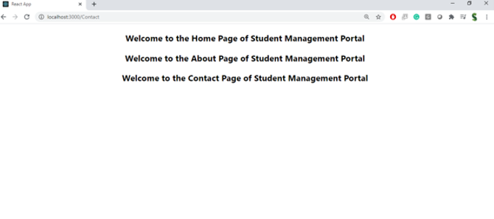

3)ReactJS-HOL

**React StudentApp: Displaying Home, About, and Contact Components**

**Program:**

**File name:mystyle.css**

.container {

padding: 20px;

margin: 30px auto;

width: 400px;

border: 2px solid #4caf50;

border-radius: 10px;

background-color: #f4f4f4;

}

h2 {

color: #333;

text-align: center;

}

p {

font-size: 16px;

margin: 10px 0;

}

**File name:CalculateScore.js**

import React from 'react';

import '../Stylesheets/mystyle.css';

function CalculateScore(props) {

const { name, school, total, goal } = props;

const average = total / goal;

return (

<div className="container">

<h2>Student Score Card</h2>

<p><strong>Name:</strong> {name}</p>

<p><strong>School:</strong> {school}</p>

<p><strong>Total Marks:</strong> {total}</p>

<p><strong>Subjects:</strong> {goal}</p>

<p><strong>Average Score:</strong> {average.toFixed(2)}</p>

</div>

);

}

export default CalculateScore;

**File name:app.js**

import React from 'react';

import './App.css';

import CalculateScore from './Components/CalculateScore';

function App() {

return (

<div className="App">

<CalculateScore

name="Nishanthi"

school="Green Valley School"

total={450}

goal={5}

/>

</div>

);

}

export default App;

**Output:**

4)ReactJS-HOL

**React BlogApp: Implementing Lifecycle Methods to Fetch and Display Posts**

**Program:**

**File name:post.js**

import React from 'react';

function Post(props) {

return (

<div style={{ marginBottom: '20px' }}>

<h3>{props.title}</h3>

<p>{props.body}</p>

</div>

);

}

export default Post;

**File name:app.js**

import React from 'react';

import './App.css';

import Posts from './Posts';

function App() {

return (

<div className="App">

<h1>Welcome to Blog App</h1>

<Posts />

</div>

);

}

export default App;

**output:**

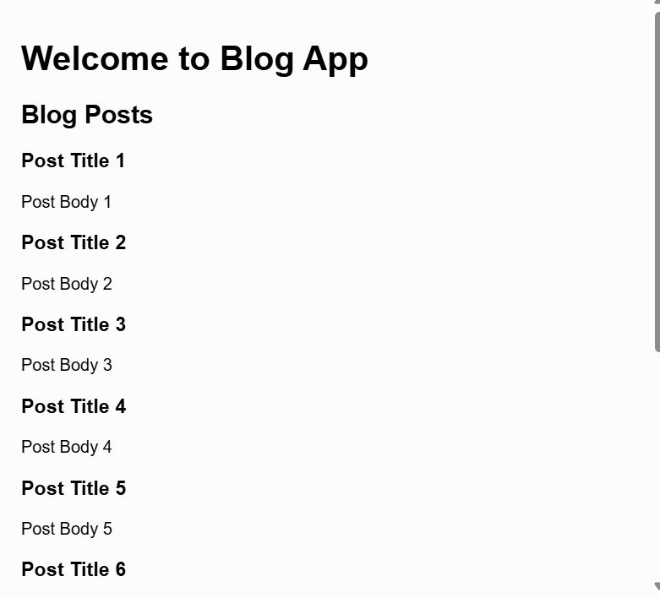

5)ReactJS-HOL

**Styling React Cohort Dashboard Using CSS Modules and Conditional Formatting**

**Program:**

**File name:module.css**

.box {

width: 300px;

display: inline-block;

margin: 10px;

padding: 10px 20px;

border: 1px solid black;

border-radius: 10px;

}

dt {

font-weight: 500;

}

**File name:cohortDetails.js**

import React from 'react';

import styles from './CohortDetails.module.css'; // CSS Module

function CohortDetails(props) {

const { cohortName, status, trainer, technology } = props;

const headingStyle = {

color: status.toLowerCase() === 'ongoing' ? 'green' : 'blue',

};

return (

<div className={styles.box}>

<h3 style={headingStyle}>{cohortName}</h3>

<dl>

<dt>Status:</dt>

<dd>{status}</dd>

<dt>Trainer:</dt>

<dd>{trainer}</dd>

<dt>Technology:</dt>

<dd>{technology}</dd>

</dl>

</div>

);

}

export default CohortDetails;

**File name:app.js**

import React from 'react';

import CohortDetails from './CohortDetails';

function App() {

return (

<div>

<h1>MyAcademy Cohort Dashboard</h1>

<CohortDetails

cohortName="Full Stack Java - Batch 10"

status="Ongoing"

trainer="Mr. Rajesh"

technology="Java + Spring Boot"

/>

<CohortDetails

cohortName="Frontend React - Batch 5"

status="Completed"

trainer="Ms. Priya"

technology="ReactJS"

/>

</div>

);

}

export default App;

**Output:**

